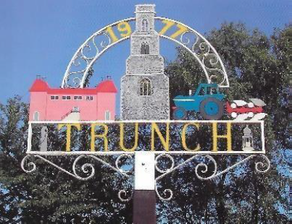

Minutes of Trunch Parish Council Extraordinary Meeting

Held on Wednesday 13th August Blacksmith Close Community Room at 8pm

Attend by: Cllrs Gaynor Houlton (Chair) David Houlton, Malcolm Bulley, Richard Miles, Alan Bowker David Burns one member of the public, Parish Clerk Tracy Neave

1. Apologies Cllrs Karen Randell, Dave Shapcott, Charlie Yaxley
2. There was a discussion to agree the response to the Planning Inspectorate regarding the proposed upgrade to Footpaths FP11 and 12 to a restrictred byway status. The Clerk to write a response on behalf of the Parish Council outlining the objection to the proposal. Points raised:

* Schedule misidentifies FP11 and FP12 completely as FP11
* States it is 6m wide: inaccurate and impassable in places
* Query as to any physical site surveys undertaken since application completed
* Concern as maintenance would be the responsibility of the parish council and could mean significant increase in Precept
* Parish Council unable to cover the cost of reinstating the byway
* Concern on environmental impact
* Council would be willing to reconsider the application being restricted to a smaller portion as a restricted byway

1. Playing field: Petanque court and maintenance basketball hoop

* Proposal for new basketball hoop: agreed
* Petanque court: A grant of £1575 is available as a contribution towards a pétanque court at the playing field. Quotes obtained from Nick Hurst (Workforce) £5000 and Dunham Groundworks £3150 exc VAT. Unanimously agreed to contract Dunham Groundworks to undertake the work

1. Matters for future meeting:

* FP5. A member of the public advised his concern over footpath FP5 which falls short at South Repps.
* Discrepancies between service delegation Norfolk County Council and contractual agreement for grass cutting

1. Date of next Parish Council Meeting 9th September 2025 7pm Trunch Village Hall

Meeting closed 1952pm