Minutes of Trunch Parish Council Meeting

Held on Tuesday 11th November 2025 at 7pm
At Trunch Village Hall

Present: Cllrs Gaynor Houlton (Chair), David Burns, Alan Bowker, Karen Randell, Malcolm Bulley, Charlie Yaxley, County Councillor Ed Maxfield, District Councillor Peter Neatherway, Clerk Tracy

- Apologies for absence: Cllrs Richard Miles, David Houlton, Dave Shapcott

- Declaration of interest for items on the agenda and to consider any requests for dispensations:
Cllr Bowker Trunch with Swafield and Bradfield Parochial Council.

- The Minutes of the meeting held on 14th October 2025 were agreed and signed by the Chair Gaynor Houlton.

- County and District Councillor Reports
  - Cllr Maxfield : report circulated prior to meeting
  - Cllr Neatherway : nothing to report
- Correspondence
  - Trod path and speed awareness communication Cllrs Maxfield and Burns: meeting to be arranged between Cllrs Maxfield, Burns and Highways.
  - Allotment lease with Diocese: Heads of Terms to be agreed once Cllrs D and G Houlton check original lease to see who is responsible for grounds maintenance.
  - There is a delay in receiving the taxbase for the Parish Precept calculation for 2026/27 and advised by North Norfolk District Council to use last financial year figure.
  - MP Steff Aquarone report circulated
  - Late correspondence Planning Inspector Local Plan circulated.
  - Late correspondence Affordable Housing flyer

- Matters Arising from previous minutes and new items
  - Assertion 10 10 AGAR reform, website changes to be carried over to new clerk
  - Energy Club: Cllr Burns discussed self-generation within an energy club as an idea for the future for the parish.

- Finance and administration:
7.1 The Bank Reconciliation was agreed and the bank statements were approved and signed by Cllr G
Houlton.
7.2 Payments agreed
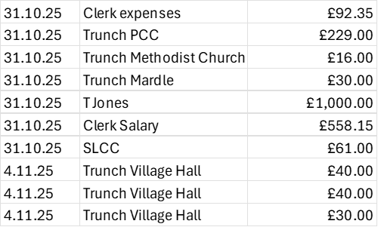
Late Payments: Tim Jones £1197, JRB Enterprises £111.06, Creative Lincs £222
7.3 It was agreed for Cllr Randell to join the Finance Group which comprises of Cllrs Bulley, Burns and
Miles.
7.4 Cllr Burns asked that funds were made available to support clearing Mundesley Road pond. This was # agreed with spend of up to £250.
7.5 Budget proposals have been received in readiness for the finance working group to present the
Budget at the December meetings.

- Highway Matters and Actions:
  - See agenda item 5.1
  - It was advised that Victory Housing in Cornish Avenue have now changed the remit of some of the housing which has resulted in pressure on available parking in that area. The Parish Council will continue to communicate with Victory Housing on how to improve parking.

- Playing Field: Cllr Yaxley had circulated a report regarding outstanding work on the playing field and potential cost. This will be discussed by the finance working group in relation to the budget.
  - Petanque Court: in progress
  - Inspection training was considered a success. The working group have met to discuss follow up from the training and will arrange for signs to have ‘what three words’ location on them in case of emergency.
  - Quotes received for play area surface with idea of staggering work over the next few years.

- Planning
  - New Planning Applications: None
  - Decisions: none
  - Appeals: none

- To receive a report and consider any actions
  - Allotments: half plot now vacant on Mundesley Road site, one allotment may be handed back to Council due to last year’s rental increase.
11.2 Community Speed: a new member has joined the team.
11.3 Neighbourhood Plan: Public drop in session planned for this week for public participation in policy
making.
11.4 Good Neighbour Scheme: there have been 144 requests for help over the last 10 months.
Warm Room: will be advised at end of month if grant application has been successful.
11.5 Environmental Group: nothing to report at present.
11.6 Footpaths: Two noticeboards have been removed in the churchyard as obsolete information on them.
FP11/12: hold no notice of previous correspondence from person who wrote letter supporting change in designation. Council to write to Public Rights of Way team/changes in clarification at Norfolk County Council for information.

- Public Participation: None

- General Parish Issues: None

- Date of next Parish Council Meeting: Tuesday 9th December 2025 at 7pm Trunch Village Hall

- Exclusion of the Press and Public under the Public Bodies (Admission to Meetings) Act 1960 to discuss the following matter:
- Following the Clerk’s resignation the recruitment process was discussed.

Meeting closed 2041pm

