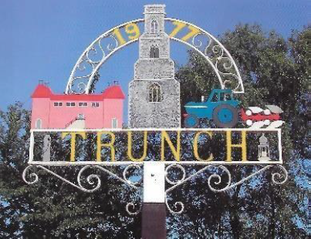

**TRUNCH PARISH COUNCIL MEETING**

**TO BE HELD ON TUESDAY 8th October 2024 AT 7PM IN TRUNCH VILLAGE HALL, KNAPTON ROAD, TRUNCH, NR28 0QE**

Councillors are summoned to, and members of the public and press are invited to attend. At item 5 the public will be invited to give their views and questions to the Parish Council on issues on the agenda or raise issues for the consideration of inclusion at future meetings. This item will generally be limited to a 30-minute duration and will first include County/District Councillors and Police reports.

*Tracy Neave Clerk to Trunch Parish Council 3rd October 2024*

**AGENDA**

1. Apologies for absence
2. To receive declarations of interest for items on the agenda and to consider any requests for dispensations

4. To confirm the Minutes of the meeting held on Tuesday 12th September 2024

5. Public Participation

5.1 Simon Biddulph Representative County Broadband

5.1 County Councillors report October sent via email

5.2 District Councillors report

5.3 Public Participation

6. Correspondence

6.1 Age Friendly North Norfolk District Council Partnership

7. Matters arising from previous minutes

7.1 Review of projects meeting

8. New items

8.1 Request from Trunch Village Hall to take up grounds maintenance

9. Periodic items

9.1 Parish Partnership Scheme

10. Finance

10.1 Bank statements and bank reconciliation

10.2 Income and Expenditure

10.3 Payment schedule: (Other late payments may be authorised)



Late payment Cllr Burns Expenses £60

10.4 St James Trust

10.5 Preparation of Budget

11. Highways

11.1 Highways Inspection Update and Actions:

11.2 To receive any other Highways matters and agree action

12. Playing Field

12.1 To receive any playing field matters and agree actions including additional grass cutting

To playing field in October and further cut in mid November

13. Planning

13.1 New Planning Application: Planning Application PF/24/1776 Warren Farm: Objections

13.2 Decisions: Nothing to report

13.3 Appeals: Nothing to report

14 Footpaths

14.1 To receive footpath matters and agree action

15 To receive a report and consider any actions

15.1 Allotments

15.2 Community Speed

15.3 Neighbourhood Plan

15.4 Good Neighbour Scheme

15.5 Warm Room/Community Cafe

16. General Parish Issues (for information only)

17. Date of next meeting: 5th November 2024