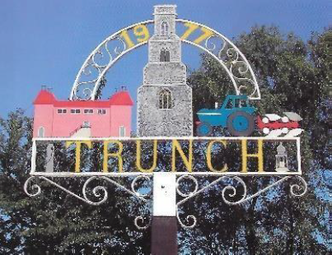

**TRUNCH PARISH COUNCIL MEETING**

**TO BE HELD ON TUESDAY 9th September 2025 AT 7PM IN TRUNCH VILLAGE HALL, KNAPTON ROAD, TRUNCH, NR28 0QE**

Councillors are summoned to, and members of the public and press are invited to attend. At item 12 the public will be invited to give their views and questions to the Parish Council on issues on the agenda or raise issues for the consideration of inclusion at future meetings. This item will generally be limited to a 30 minutes duration.

*Tracy Neave Clerk to Trunch Parish Council 4th September 2025*

**AGENDA**

1. Apologies for absence
2. To receive declarations of interest for items on the agenda and to consider any requests

for dispensation

1. To confirm the Minutes of the meeting held on 8th July 2025 and 13th August 2025

4. County and District Councillors Reports

4.1 County Councillors report

4.2 District Councillors report

5. Correspondence

5.1 None received or to be discussed in agenda item

6. Matters Arising from previous minutes and new items.

6.1 20mph speed limit

6.2 Almanac and workload activity documents

6.3 Service level agreement verge and path cutting

7. Finance and Administration

7.1 Bank statements and bank reconciliation: no bank statement available at time

Of advertising agenda

7.2 Payment schedule: see end of agenda for payments during July and August



7.3 To appoint internal auditor for 2025/26

8 Highways

8.1 To receive any Highways matters and agree actions

9. Playing Field: to receive any playing field matters and agree actions including working

group recommendations

9.1 Update on fencing issue

9.2 Update on pétanque court

9.3 Training for playground inspection

10. Planning

10.1 New Planning Applications

10.2 Decisions: for PF/25/0510 Rookery Farm Barn, Mundesley Road,demolition of barn

and removal of conifer hedge, change of use of land from agriculture to residential

garden, conversion of store building to domestic workshop/garden store: approved

For LA/25/0958 White House Farm, Mundesley Road: Various works - replacement of

existing kitchen door and removal of brick pier on the east elevation -approved

10.3 Appeals

11. To receive a report and consider any actions

11.1 Allotments including feedback from allotment inspection

11.2 Community Speed

11.3 Neighbourhood Plan including progress report and policies

11.4 Good Neighbour Scheme

11.5 Environmental Group

11.6 Footpaths: including Inspectorate objection submitted, and acknowledgement received.

to discuss call for comments on points raised and feedback on FP5 from extraordinary

meeting held on 5th August 2025

12. Public Participation

13. General Parish Issues (for information only)

14. Date of next Parish Council Meeting 7th October 2025 7pm Methodist Hall

